NEWF_Visualizer User Instruction Document

Overview
NEWF_Visualizer is a Python-based tool designed to visualize global interactions among food, water, and energy resources. It produces interactive maps and time‑series plots at the country level, automatically loading all required datasets. The tool is optimized for use in Google Colab, requiring minimal setup from the user.
All generated visualizations are saved automatically in HTML format, making them easy to explore, archive, or embed in reports and websites.

Key Features
- Automated data loading: No manual downloads required.
- Interactive plots: Hover over any country to view specific values.
- Multiple visualization types: Global maps and country‑level time series.
- HTML export: All plots saved for future interactive use.
- Google Colab compatibility: No local installation needed.

Requirements
- A Google account.
- Access to Google Colab.
- Basic understanding of Python (recommended but not required).

Getting Started in Google Colab
- Open Google Colab at https://colab.research.google.com.
- Upload or open the notebook that contains the NEWF_Visualizer code.
- Ensure the notebook and the NEWF_Visualizer script are in the same working directory, or that the script is loaded from a GitHub repository.
- Run all cells in order.

Running NEWF_Visualizer
From the UNU Github Folder (https://github.com/unu-inweh/WEF-Nexus), select the “NEWF_Visualizer_Final.ipynb” file and click on “Open in Colab” button. You will need to login to Google Colab using your Google credentials.
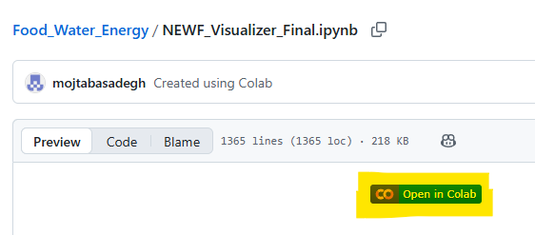

After opening the visualizer code in Colab, click on “Run all”. It will take several minutes to load all the data, and make all the plots. You may need to give access to your Google account to Colab (it is safe to do so).
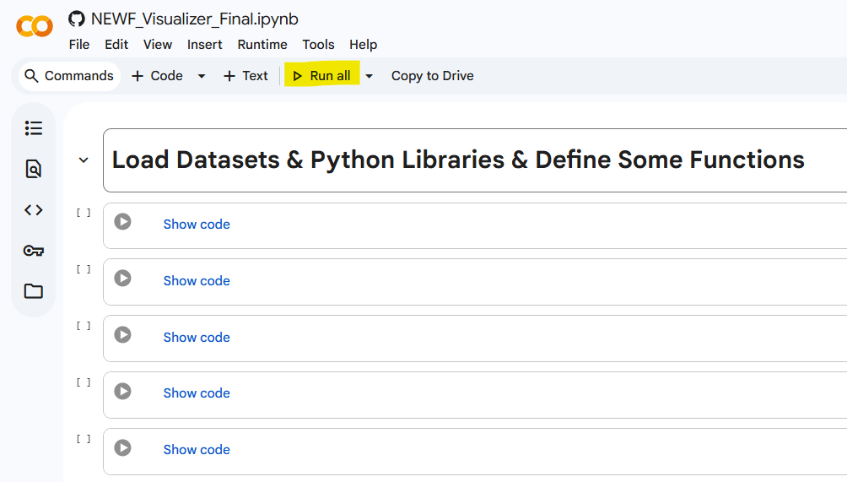

Troubleshooting: If you have already run the code, made changes, and it does not work as before, click on “Runtime” and select “Restart session and run all”.
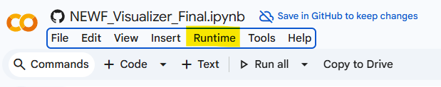

There are multiple sections generating different maps and graphs. In each section, multiple graphs are made, but the user can modify the code according to the instructions to plot the variable of interest.

When you change code, you should press “Ctrl” + “Enter” to rerun the code cell. When using dropdown menus to change selected variables, you do not need to rerun the code.

All the plots will be saved in a temporary folder and can be downloaded following the below steps:
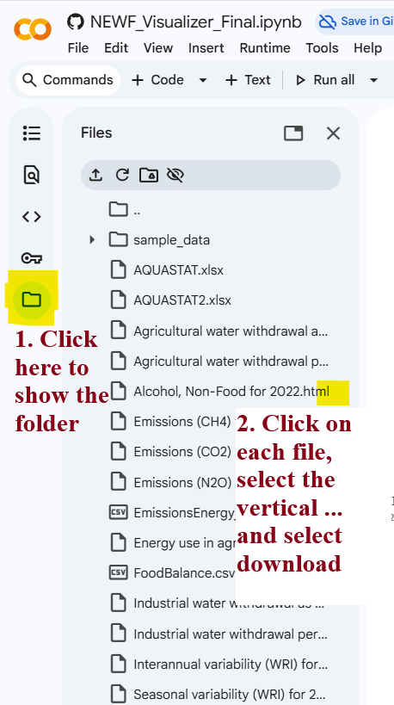

Note that the script will automatically:
  - Load all required global datasets for food, water, and energy.
  - Generate interactive maps (e.g., resource availability, consumption, production).
  - Create time‑series plots for each country.
  - Save all visualizations in HTML format in the working directory.

Viewing the Interactive Plots
- When running in Google Colab, the plots will display directly beneath each cell.
- You can hover over each country to display:
  - Numerical values
  - Units (e.g., GWh, km³, tonnes)
  - Metadata depending on the dataset
- Saved HTML files can be opened in any modern web browser.

Output Files
The tool saves visualizations in HTML format which can be opened in any browser such as Chrome.
These files remain fully interactive when opened outside Colab.

Tips for Effective Use
- Use the Colab “Reconnect” or “Factory Reset Runtime” options if memory becomes limited.
- Download HTML files regularly to avoid losing outputs when Colab resets.
- You can embed the interactive HTML files into external dashboards or websites.

Troubleshooting
Issue: Maps fail to load. - Ensure all required packages (e.g., Plotly, Pandas) are installed in the Colab environment. - Re‑run the initialization cell.
Issue: HTML files not saving. - Verify that you have write permission in the Colab working directory. - Confirm the script’s output path.
Issue: Hover tooltips not appearing. - Try opening the HTML file in another browser. - Check that Plotly rendering is enabled in Colab.

9. Conclusion
NEWF_Visualizer offers an intuitive and automated way to explore global food‑water‑energy (NEWF) dynamics. Its interactive features and seamless Google Colab integration make it suitable for researchers, educators, and analysts working on global resource systems.
For further customization or integration into larger workflows, the code can be extended or embedded into new analytical pipelines.

